|  |
| --- |
| The University of hull |
| [Document title] |
| [Document subtitle] |

|  |
| --- |
| Ieaun Roberts  [Date] |

# Abstract

Original Project Description

“This project aims to produce a LoRaWAN gateway that is able to secure private data whilst still allowing the gateway to route public data to The Things Network.

Public users commonly utilise 'The Things Network' (TTN) to connect endpoints and gateways. The more of these that are available, the more useful and usable LoRaWAN is for all. However, private companies are often uncomfortable with their data being shared with third parties. This drives them to create their own LoRaWAN infrastructure and not connect their gateways to TTN.  
  
This project seeks to offer public connection to TTN but gateway-level private filtering for registered endpoints. Data from unregistered/unknown endpoints is still sent to TTN as usual. Private data is filtered out and not sent to the TTN servers - instead the data would be sent to privately owned servers for storage/use. This means that protected data is secured whilst ensuring that the gateway is still useful to the public.”

Contents

Abstract 1

Introduction 3

What is LoRa 3

What is LoRaWan 4

Aims and Objectives 5

Background 6

Hardware systems 7

LoRaWan gateways and end nodes 8

Small scale projects 8

Technical background 9

Development 10

Project management 10

Critical evaluation 11

Definition of done 11

Technical achievements 11

Problems faced; lessons learnt 11

Conclusion 12

Appendix 13

# Introduction

Lpwan – Low Power Wide area network, wireless communication for sending small data packages over long idstances usdually powered by battery. Technologies inlcued Narrowband IoT (NB-IoT), Sigfox, lora and others. 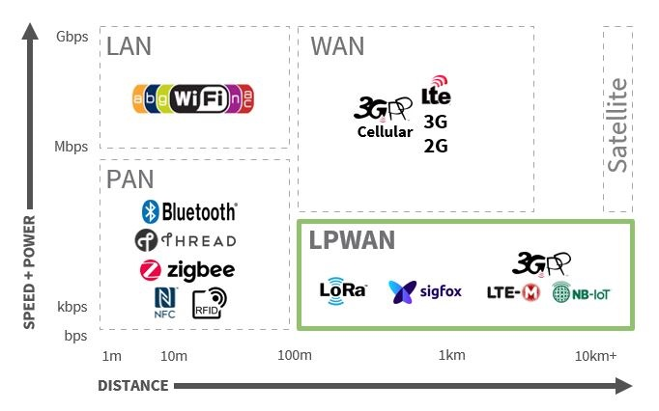

**Figure , Wireless technologies.**

## What is LoRa

“LoRa (Long Range) is a low-power wide-area network protocol developed by Semtech. It is based on spread spectrum modulation techniques derived from [chirp spread spectrum](https://en.wikipedia.org/wiki/Chirp_spread_spectrum) (CSS) technology.

LoRa uses license-free sub-gigahertz [radio frequency](https://en.wikipedia.org/wiki/Radio_frequency) bands like 433 MHz, [868 MHz (Europe)](https://en.wikipedia.org/wiki/Short-range_device#SRD860), 915 MHz (Australia and North America) and 923 MHz ([Asia](https://en.wikipedia.org/wiki/Asia)). LoRa enables long-range transmissions (more than 10 km in rural areas) with low power consumption.

The technology covers the [physical layer](https://en.wikipedia.org/wiki/Physical_layer), while other technologies and protocols such as LoRaWAN (Long Range Wide Area Network) cover the upper layers.”

-Wikipedia (Wiki, 2020)

Speed (0.3 – 5.5 kbps) - mobilefish

LoRa spread spectrum is a patented modulation technique developed by semtech based on spread spectrum modulation. LoRa provides long-range and low power consumtion, a low data rate and secure data transitions. LoRa can be used with public/private and hybrid networks to achieve a greater range thjan cellular networks

LoRa’s range is largely dependent on the environment of its use case and the materials used within.

|  |  |  |
| --- | --- | --- |
| Environment | Range (km) |  |
| Urban | 2-5 |  |
| Rural | 5-15 |  |
| Direct line of sight | >15 |  |

Record: 436 miles / 702Km, Weather balloon to ground connection (TTN, 2017)

Lora Node

Usually battery powered device making use of a sensor. Sensor data is transmitted to a gateway.

Lora Gateway

* Connected to the internet,
* receives data from end nodes.
* Multiple end nodes can receive the same data.
* Gateways can listen to multiple frequencies simultaneously

LoRaWan protocol does not support direct communication between end nodes. Need to use Radiohead if you want to do this.

## What is LoRaWan

“Since LoRa defines the lower physical layer, the upper networking layers were lacking. LoRaWAN is one of several protocols that were developed to define the upper layers of the network. LoRaWAN is a cloud-based [medium access control](https://en.wikipedia.org/wiki/Medium_access_control) (MAC) layer protocol but acts mainly as a network layer protocol for managing communication between [LPWAN](https://en.wikipedia.org/wiki/LPWAN) [gateways](https://en.wikipedia.org/wiki/Gateway_(telecommunications)) and end-node devices as a routing protocol, maintained by the LoRa Alliance.

LoRaWAN defines the communication protocol and system architecture for the network, while the LoRa physical layer enables the long-range communication link. LoRaWAN is also responsible for managing the communication frequencies, [data rate](https://en.wikipedia.org/wiki/Data-rate_units), and power for all devices.

Devices in the network are asynchronous and transmit when they have data available to send. Data transmitted by an end-node device is received by multiple gateways, which forward the data packets to a centralized network server.[[11]](https://en.wikipedia.org/wiki/LoRa#cite_note-:0-11) The network server filters duplicate packets, performs security checks, and manages the network.

Data is then forwarded to application servers.[[12]](https://en.wikipedia.org/wiki/LoRa#cite_note-12) The technology shows high reliability for the moderate load, however, it has some performance issues related to sending acknowledgements.”

-Wikipedia (Wiki, 2020)

|  |  |  |  |  |  |  |
| --- | --- | --- | --- | --- | --- | --- |
| Technology | Peak data rate | Bandwidth | Range/ Penetration | Duplex mode | Power consumption | Price |
|  | <100kbps | 200 KHz | Low | Half | Low | £ |
|  | Up to 1Mbps | 1.4 MHz | Medium | Full/Half | Meduim | ££ |
| LTE-Cat-1 | Up to 10Mbps | 20 MHz | High | Full | High | £££ |
|  |  |  |  |  |  | £ |
|  |  |  |  |  |  |  |
|  |  |  |  |  |  |  |

(electronicspecifier, 2020)

# Aims and Objectives

1. Initial system set up phase:
   1. Conduct extensive research into the topic
   2. Produce a LoraWan gateway that is capable of receiving communications from an end node.
   3. Add functionality:
      1. Enable it to forward packets received to:
         1. The TTN
         2. Private servers
      2. Differentiate between public and private packets.
      3. Option to encrypt packets.
   4. Produce a LoRaWan gateway that is able to secure private data whilst still allowing the gateway to route public data to the things network.
2. Exploration of use cases / experiments phase:
   1. Examine each of the outlined use cases and produce several experiment results on selected use cases.
      1. Outline short comings.
      2. Research possible improvements.
      3. Security concerns.
3. Further development phase:

# Background

## Use cases

#### Smart utilities

#### Health and hygiene

#### Safety

#### Efficiency

#### Agriculture

Off grid mobile phone messaging (Skrypt, 2019)

IP over LoRaWan (Cola, 2018)

Lora operates in the unlicensed ISM bands (Industrial, scientific and medical) used for purposes other than telecommunication, it is possible to view a more in depth breakdown of specific frequencies in lora per country by visiting <https://www.thethingsnetwork.org/docs/lorawan/frequencies-by-country.html>

In Europe use of the ism bands are limited to 0.1% and 1% duty

Max antenna gain is +2.15 dbi

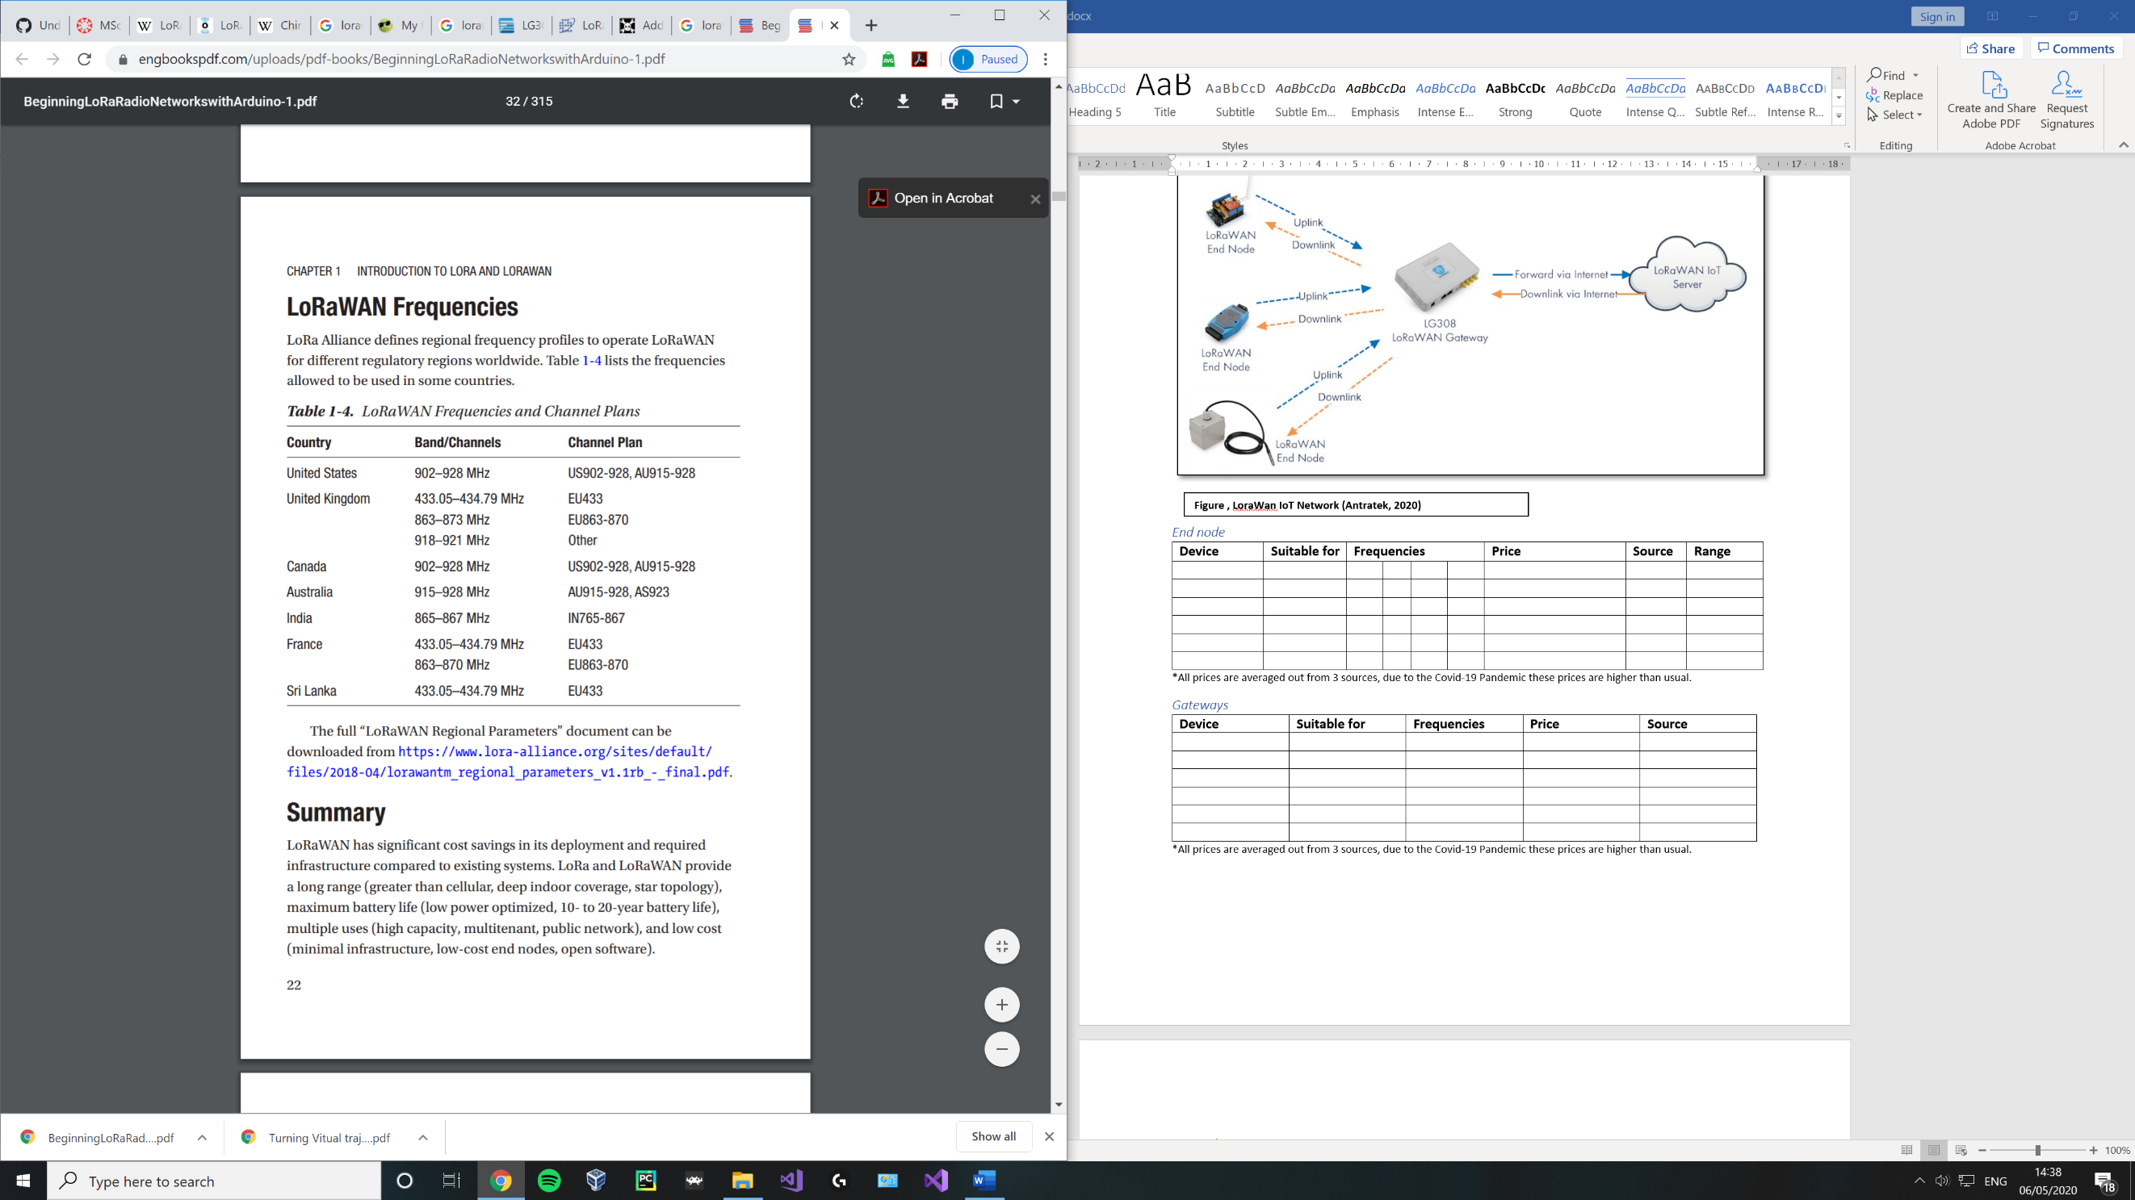

**Figure , LoraWan IoT Network** (Seneviratne, 2019)

#### The things network

Fair use policy limits user:

* uplink air time to 30 seconds per 24 hours per node
* downlink messages are limited to 10 messages per 24 hours per node

Mobile fish 3

Time on air – time it take a senders packet to reach a receiver.

Duty cycle – proportion of time during which a component, device or system is operated, can be expressed as a ratio or percentage.

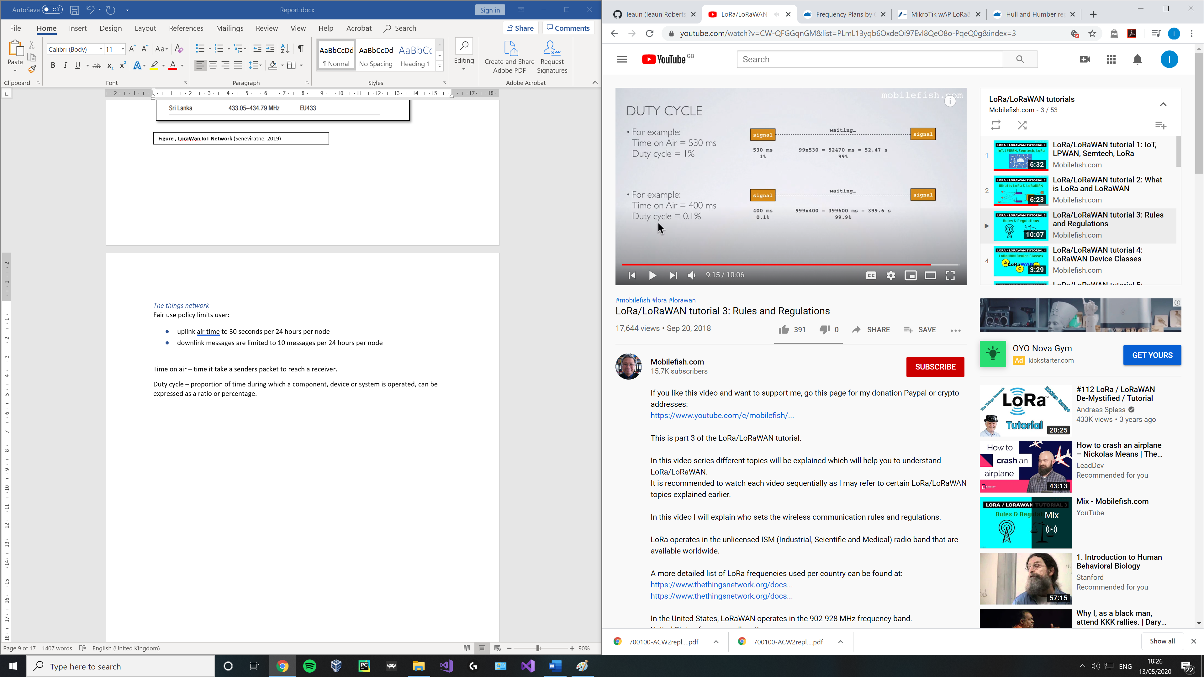

This needs to be in place otherwise anyone can broadcast an unlimited amount rendering the band useless.

Mobile fish 4

LoRaWan spec defines 3 device classes

1. All – battery powers, each device uplink to the gateway and is followed by two short downlink reciece windows
2. Beacon- same as class a but open extra receive windows
3. Continuous - same as a but continuously lison, use far more power and are often mains power

1 at any time an endnode can broadcast a signal, after this transmission the end node will listen for a response from the gateway.The end node opens 2 reciving slots, one at time T1 and another at time T2. The gateway can respond within the first or second slot but not both.

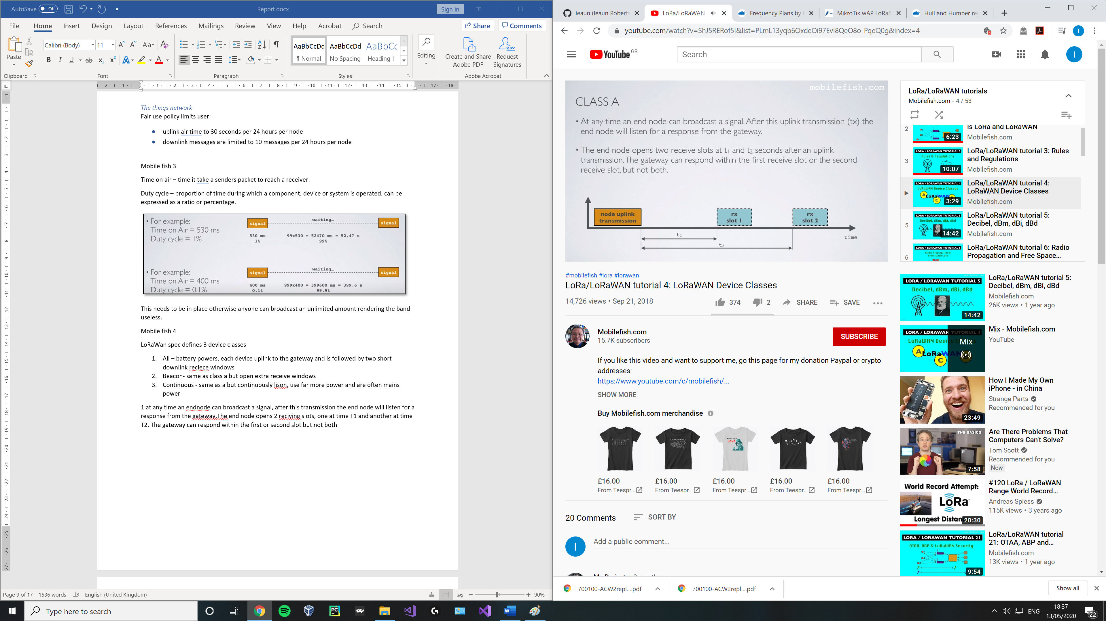

2 class b devices do class a but open extra receive slots at scheduled time, the end node receives a time sycronized beacon from the gateway allowinf the gateway to know when the node is listening. Class B does not support class C funcitonmlity

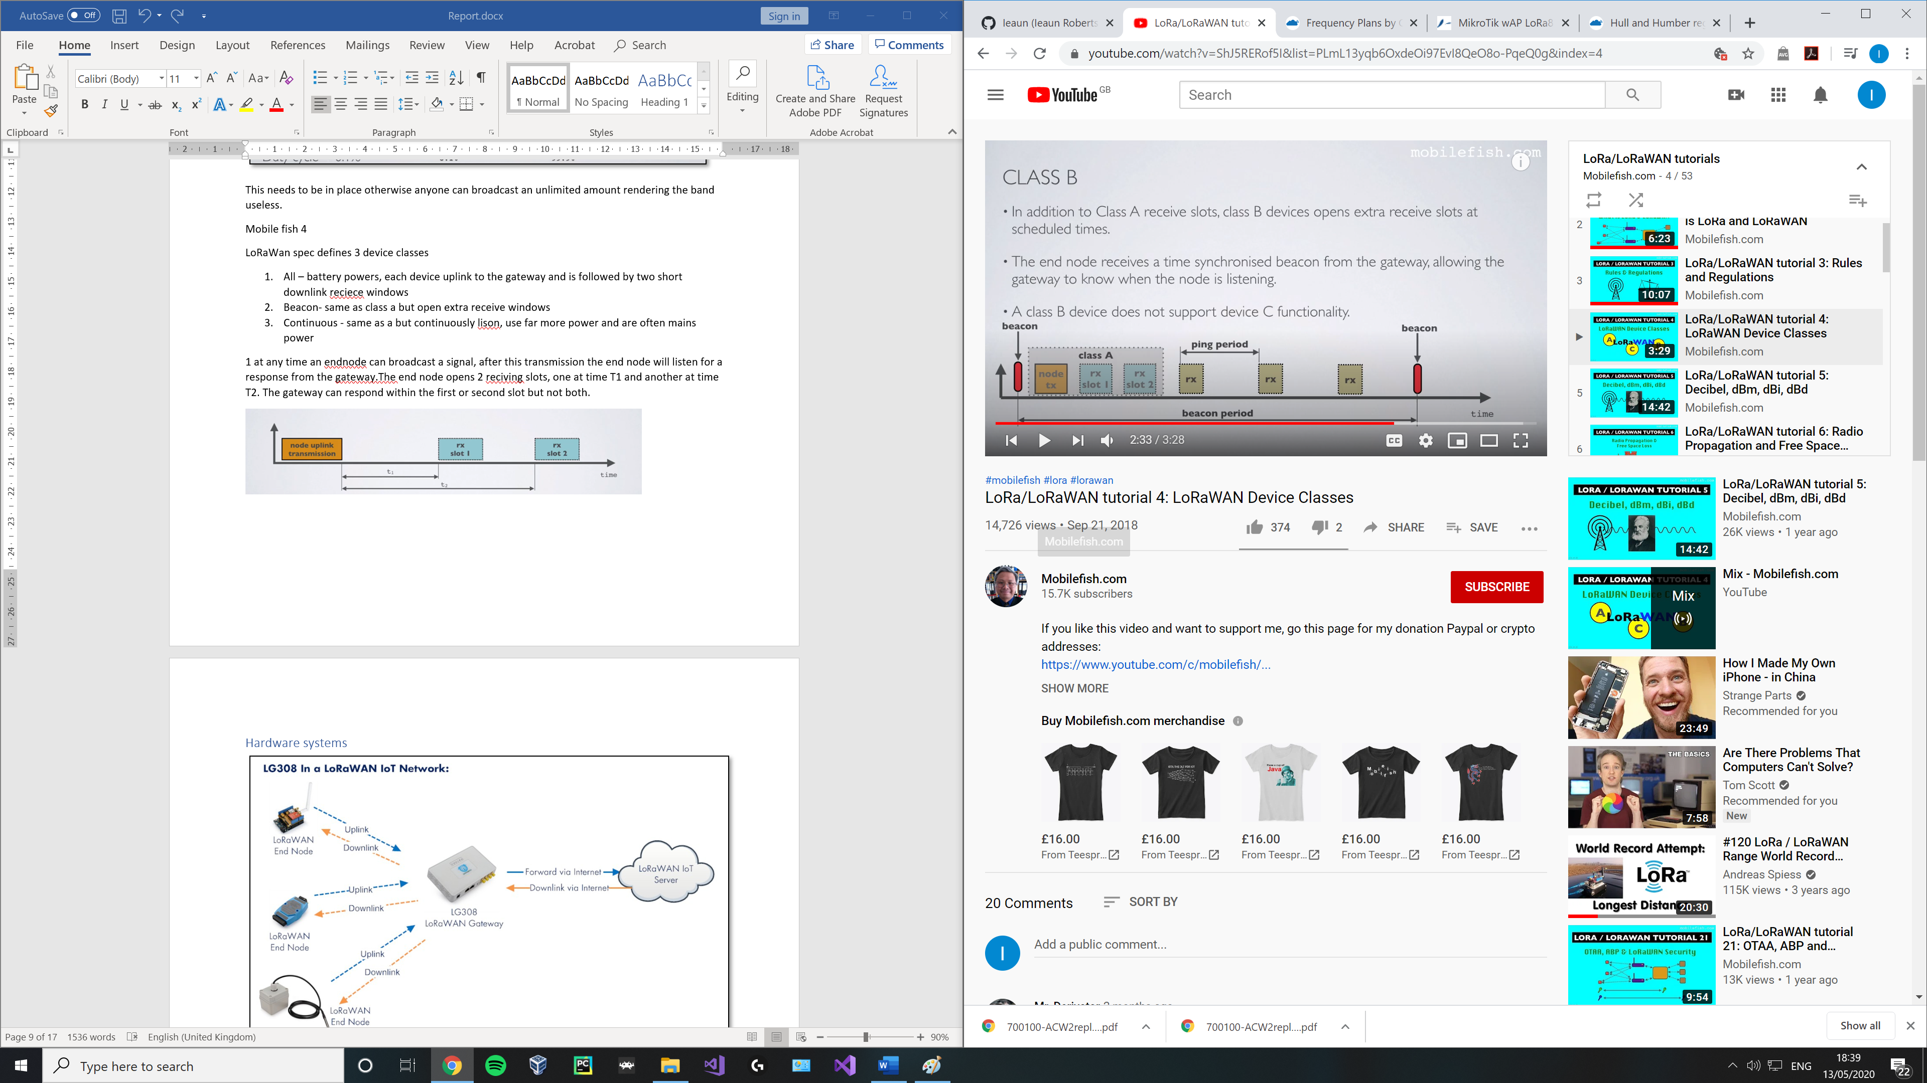

3 class c does a and then also listens continuously for responses from the gateway. Class c does not support class b functionality

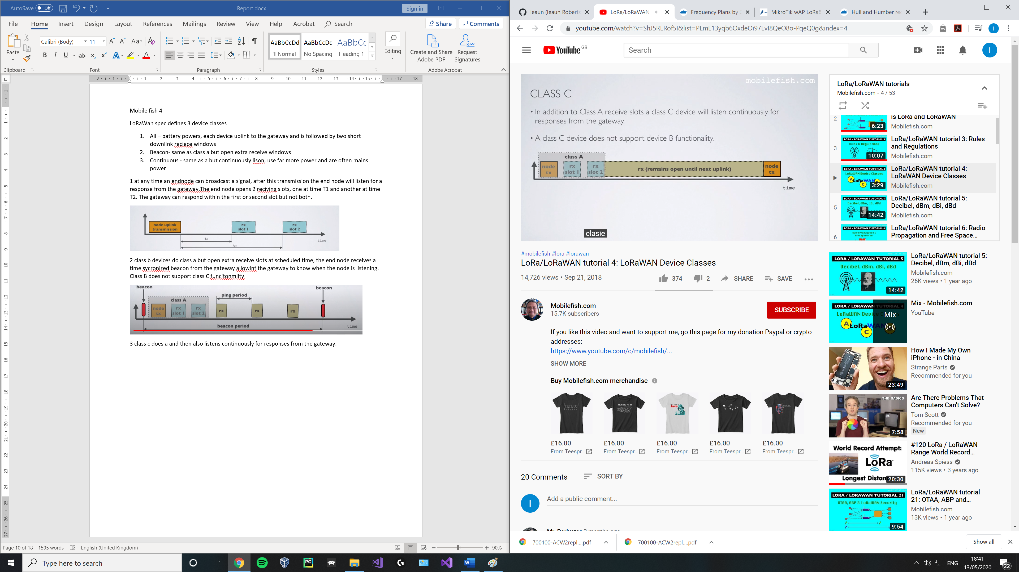

## Hardware systems

**Figure , LoraWan IoT Network (Antratek, 2020)**

## LoRaWan gateways and end nodes

Due to the cost of particular devices, some may only be feasibility in certain use cases. In this section end nodes and gateways are split into 2 sub sections, being either for use in small scale projects (with a price cap of x amount **overall\***) or industry use (with no price cap).

1. Microcontroller
2. LoRa radio module
3. Microcontroller

Semtech has licenced the LoRa ip to a handful of chip manufacturers such as HopeRF and Microchip.

*This includes the price of the microcontroller / board needed to use the device

(semtech, n.d.) (dragino, 2019) (Supply, n.d.)

#### Chips in End nodes

|  |  |  |  |  |  |  |
| --- | --- | --- | --- | --- | --- | --- |
| **Manufacturer** | **Chipset** | **Max link budget** | **Sensitivity (dBm)** | **Interface** | **Remarks** | **Image** |
| Microchip | RN2483 |  | -139 / 20 | UART |  |  |
| Semtech | SX1276/ 77/78/79 | 168 | -148 | FSK, GFSK, MSK, GMSK, LoRa and OOK (UART) |  |  |
| Semtech | SX1272/73 | 157 | -137 | FSK, GFSK, MSK, GMSK, LoRa and OOK (USART) |  |  |
| HOPERF / RF Solutions | RFM9xW | 168 | -148 | OOK and (G)FSK | Based on SX1276 / 78 |  |
| Rak | RAK811 |  |  | UART | Based on SX1276 |  |

#### End node

|  |  |  |  |  |
| --- | --- | --- | --- | --- |
| **Device** | **Modules** | **Notes** | **Device** | **Price** |
| Dragino LoRa Shield | RFM95W |  | Arduino | £20.27 |
| LORA CLICK | RN2483 | Can swap between 433/868 frequencies |  | £42.05 (or £48.60 for 5) |
| I-NUCLEO-LRWAN1 | SX1272 | Accelerometer, humidity, magnetometer, pressure and temperature sensors | Arduino | £23.64 |
| Dragino 113990254 | Based on SX1276/SX1278 | Lora/GPS | Raspberry Pi | £26.68 |
| Dorji (DRF1276DM) | SX1276 |  |  | £9.10 |
| DM164138 | RN2483 | All in one device with built in sensors / LCD. |  | £56.14 |
| RAK811 LPWAN | RAK811 | Arduino shield / stand alone device. | Arduino | £17.17 |
| RAK811 LoRa / TrackerBoard | RAK811 | GPS, open source |  | £40.99 |

*All prices are averaged out from 3 sources, due to the Covid-19 Pandemic these prices are higher than usual.

#### Gateways

|  |  |  |  |  |
| --- | --- | --- | --- | --- |
| **Device** | **Suitable for** | **Notes** |  | **Price** |
| Mikrotik, LoRa8 |  |  |  | £156.59 |
|  |  |  |  |  |
|  |  |  |  |  |
|  |  |  |  |  |
|  |  |  |  |  |
|  |  |  |  |  |

*All prices are averaged out from 3 sources, due to the Covid-19 Pandemic these prices are higher than usual.

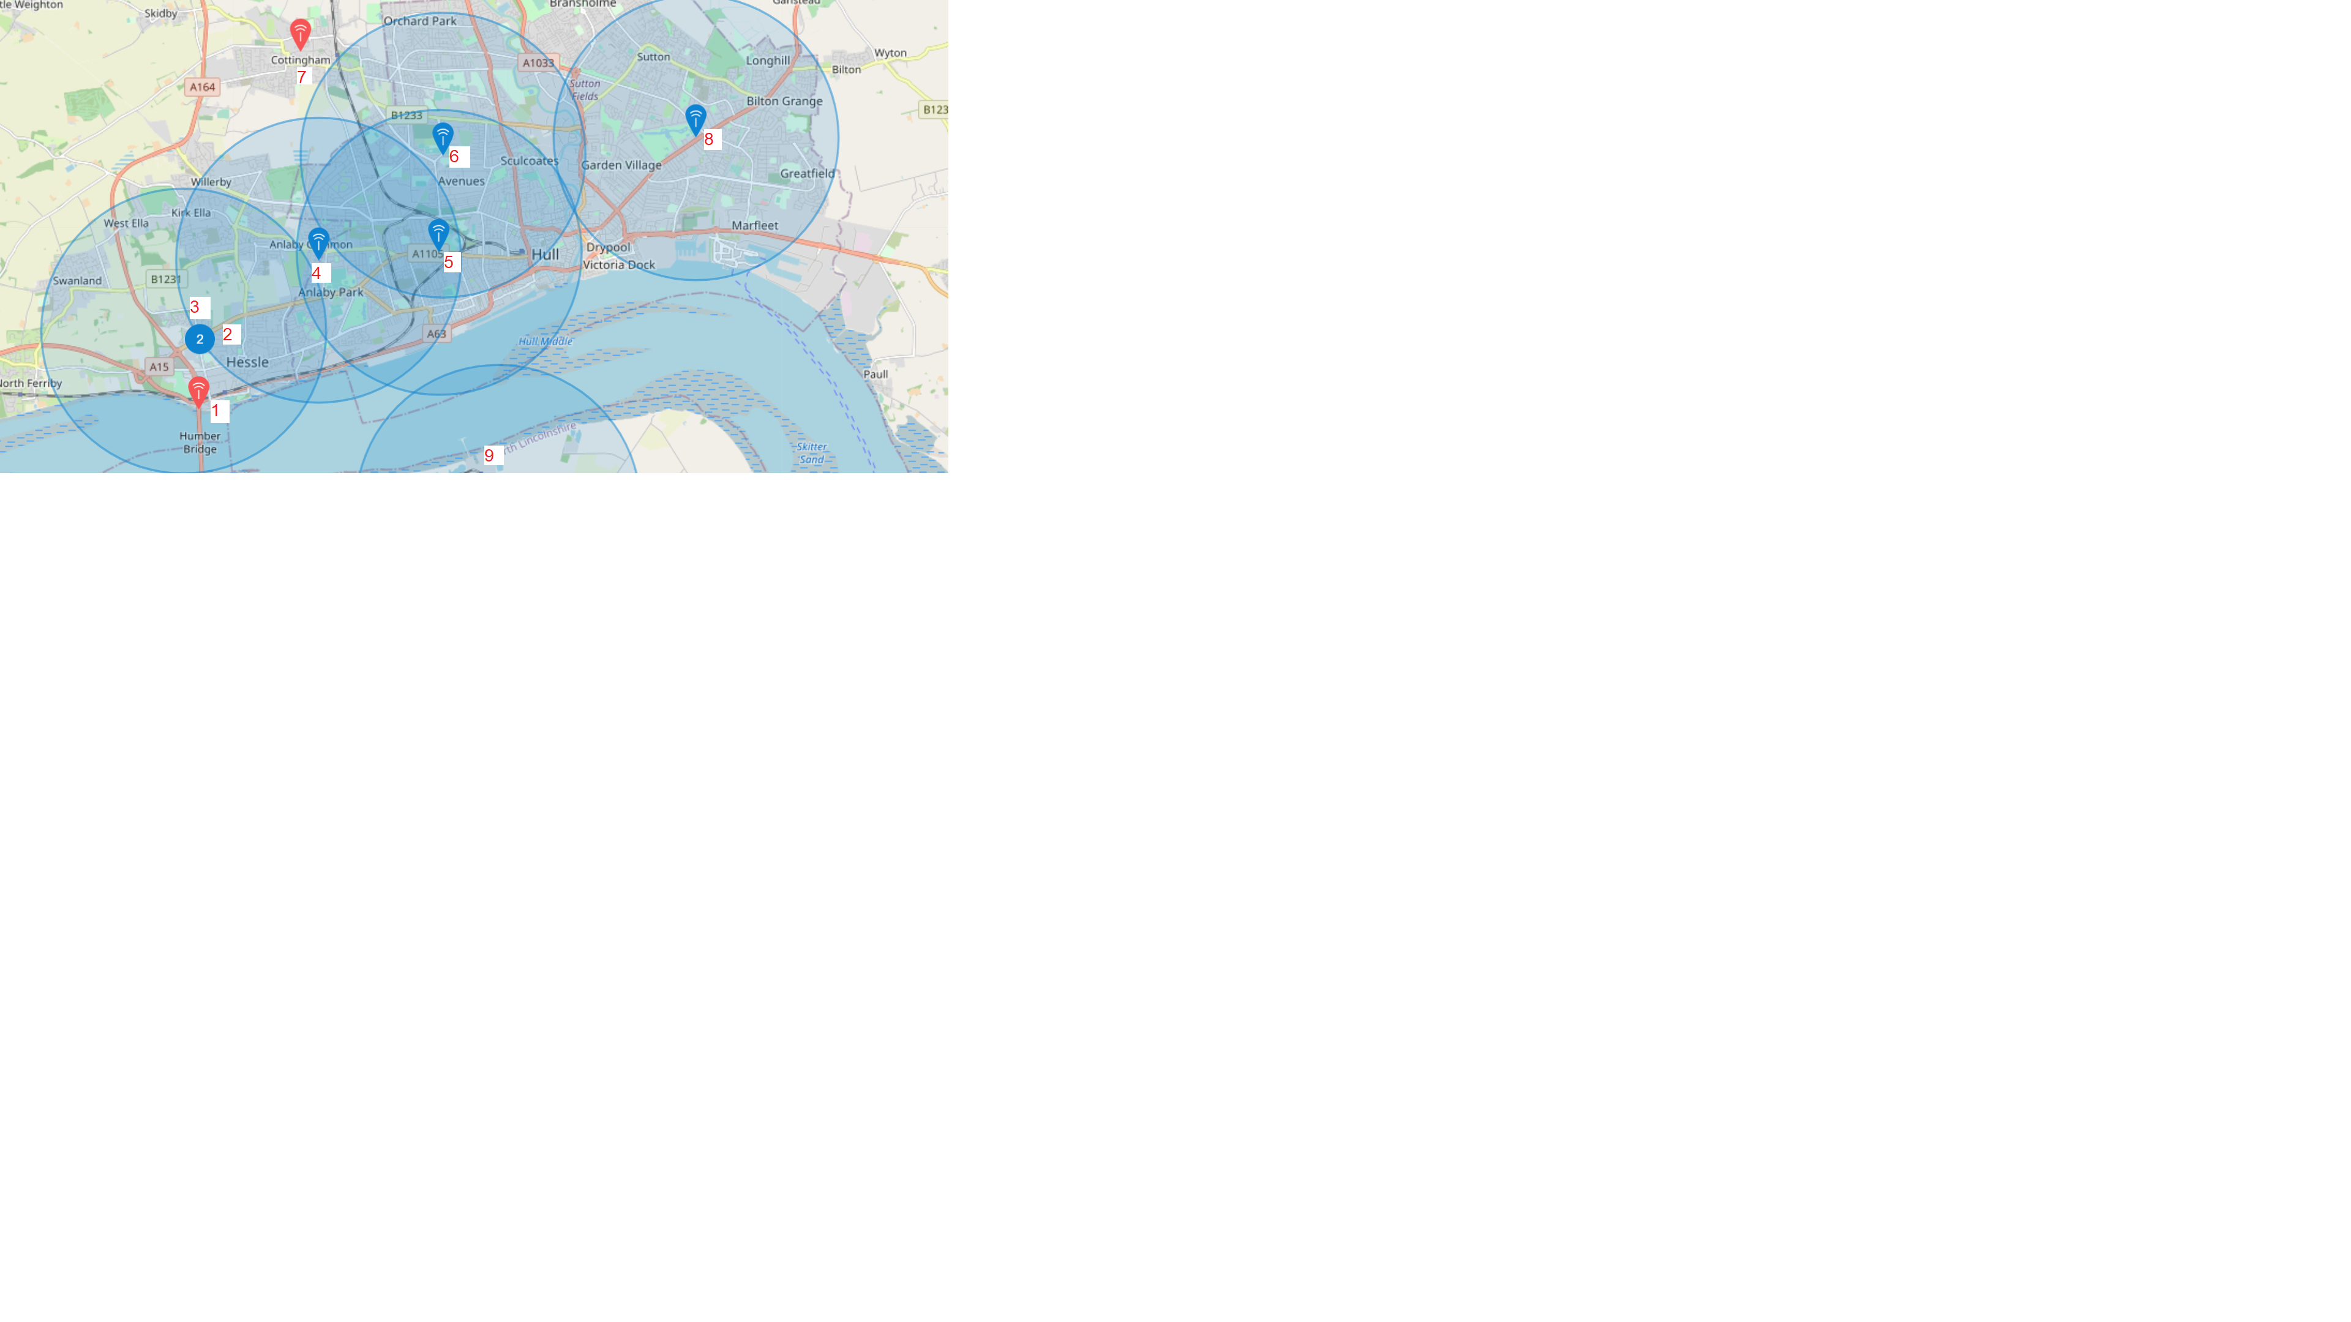

**Figure , LoRaWan gateways in Hull, UK**

#### What gateways are others using ?

|  |  |  |
| --- | --- | --- |
| No | Brand / Model | Altitude (m) |
| 1 | - | 150 |
| 2 | Raspberry Pi based, IMST | 34 |
| 3 | The Things Gateway | - |
| 4 | Raspberry Pi based, RAK831 | 1 |
| 5 | Raspberry Pi based, IMST | - |
| 6 | Raspberry Pi based 3 - 868.5Mhz | 8 |
| 7 | The Things Indoor Gateway | - |
| 8 | Mikrotik, LoRa8 | 15 |
| 9 | Mikrotik, LoRa8 | 5 |

## Technical background

Chirp spread spectrum

# Development

## Project management

# Critical evaluation

## Definition of done

## Technical achievements

## Problems faced; lessons learnt

# Conclusion

# Appendix

